**Introduction**:

A sensor is “a device that responds to a physical stimulus such as heat, light, sound, pressure, magnetism, or a particular motion, and transmits a resulting impulse for measurement or operating a control” (Merriam-Webster 2017). Typically, sensor data can be used to detect early signs of biotic (biological in nature) or abiotic (water, solar radiation, temperature, air quality) crop stress. When combined with various sampling methods (i.e., ground or aerial), sensor extracted data can be useful to farmers for monitoring plant growth and health. It can also help in potential crop yield estimation [WSU EXTENSION | UNMANNED AERIAL SYSTEMS IN AGRICULTURE: PART 2 (SENSORS)].

Sensors that capture and record natural EM radiation coming from the sun and reflected from the objects are termed as passive sensors. Most optical sensors used in agricultural remote sensing often are of passive type. Active sensors are integrated with specific energy source to illuminate the object and record the response. For example, the light detection and ranging (LiDAR) and ultrasonic sensors, respectively, use infrared light and short sound pulses as energy sources to capture ToF data. For example, a LiDAR sensor (from SICK Inc., Germany) emits infrared light (905 nm) in the sensor FOV and measures the response as reflected light intensity with distance.

The agriculture industry, including farmers who rely on advanced technologies, increasingly use lidar data for crop management to enhance agricultural productivity. Annually, the combination of greater yields and reduced crop losses is estimated to increase revenue by $2 billion for America’s farmers when terrain data derived from lidar are made available for all high-quality croplands. [ <https://pubs.usgs.gov/fs/2016/3088/fs20163088.pdf>]

**Precision Agriculture:**

Precision agriculture, also known as precision farming, is a broad term commonly used to describe particular farm management concepts, sometimes referred to as satellite farming or site specific crop management (SSCM). The term first came into popular use with the introduction of GPS (global positioning satellites) and GNSS (global navigation satellite systems) as well as other methods of remote sensing which allowed farm operators to create precision maps of their fields that provide detailed information on their exact location while in-field. Advancements in technology have enabled the practice of precision agriculture to expand, providing even greater advantages for farmers and agricultural operations, including yield monitoring and crop scouting. [ <http://www.farms.com/precision-agriculture/>]

**Necessity of Lidar in precision agriculture:**

Lidar for precision agriculture applications that improve terrain characterization for site-specific applications of seed, fertilizer, lime, pesticides, and water, which leads to increased farm yields, improved resource efficiency, and reduced chemical use. Laser scanning systems can be used to create digital elevation models which allow for inspection into slopes and landscape positions to identify 3D changes over time. LiDAR applications in Agriculture can assist with mapping water flow and catchments and monitoring erosion and soil loss

[https://www.3dlasermapping.com/lidar-applications/agriculture-technology/].

**Optical sensing in Precision agriculture**:

Optical sensing is used within agriculture to measure variability within soil and vegetation and uses the visible, Near Infra-Red (NIR) and thermal portions of the electromagnetic spectrum. In precision agriculture the most common bands used are the **red** and **NIR** bands as the reflectance of these wavelengths can be correlated to plant physiology.

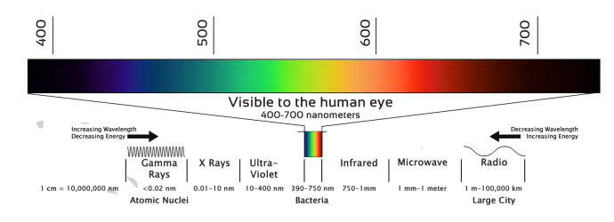

**Figure 1: Electromagnetic Spectrum**

[ Source-http://www.nuffieldscholar.org/news/davina-fillingham-report-published]

In healthy actively growing plants blue light and red light from the visible spectrum are strongly absorbed by the plant chlorophyll pigment inside the leaf cell chloroplasts, to provide energy for photosynthesis. All healthy plants reflect more green light, and less blue and red light as they are absorbed by the plant, as illustrated below.

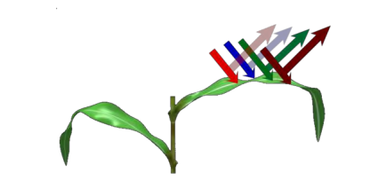

**Figure 2: NIR light reflectance from vegetation**

Near Infra-Red Light (NIR) meanwhile is strongly reflected in healthy actively growing plants. Therefore, healthy plants display a low red light but high NIR reflectance. Plants under stress will absorb less red light as the chlorophyll activity decreases causing a decrease in NIR reflectance.

**Lidar:**

LIDAR (Light Radar) refers to a device where the distance to objects in the plane of the device is measured with some specified update rate. As the name suggests the device uses light, typically a laser beam, for measuring. The output of the device can be represented as a two-dimensional map with the device in the center and dots representing the distance to the objects surrounding it.

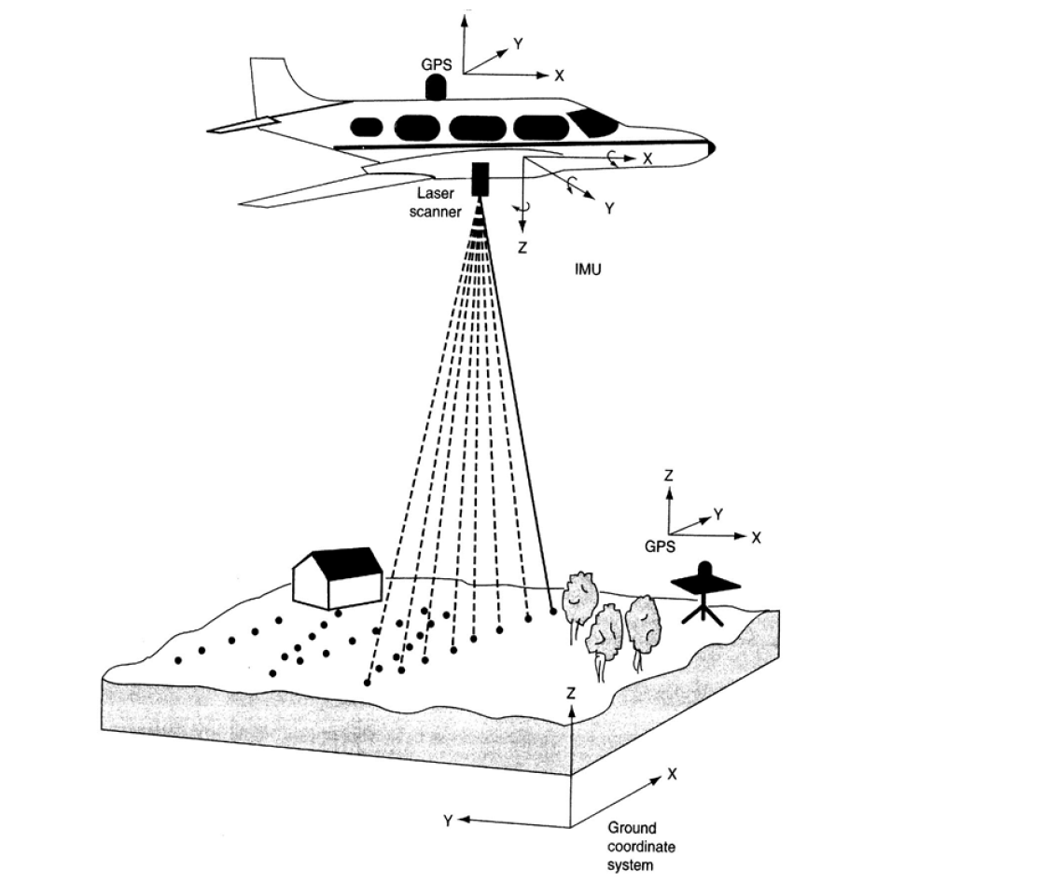

**Figure 3: Airborne Lidar application in agricultural analysis**

[http://web.pdx.edu/~jduh/courses/geog493f12/Week04.pdf]

**General Lidar design considerations:**

1. **Lidar Arrangements**
2. **Biaxial:** In the biaxial arrangement, the laser beam and the receiver axis are separated, and the laser beam only enters the ﬁeld of view of the receiver optics beyond some predetermined range. It helps avoiding near-ﬁeld backscattered radiation that may saturate photo-detector.
3. **Coaxial:** In the coaxial arrangement, the axis of the laser beam is coincident with the axis of the receiver optics. Therefore, the receiver can see the laser beam since the zero-range bin. (There are debates on this point – depending on the telescope structure!). The near-ﬁeld backscattering problem in a coaxial system can be overcome by either gating of the photo-detector or use of a fast shutter or chopper to block the near-ﬁeld scattering.

The choice of biaxial or coaxial arrangement is usually determined by the detection range. If near-ﬁeld range is desired, coaxial arrangement is preferred as it provides full overlap of receiver ﬁeld-of-view with laser beam. If near-ﬁeld range is not desired, biaxial arrangement may help prevent the saturation of photo-detector by strong near-ﬁeld scattering. Scanning capability can also come into play for the selection of biaxial or coaxial.

1. **Up looking or Down looking**

Ground based lidars are usually up looking, while spaceborne lidars are usually down looking. Airborne lidars can be either up looking or down looking, depending on application needs.

The reason to care about up- or down-looking is the fact that atmospheric density decreases with altitude nearly exponentially. So, the signal strength for up- or down-looking lidars will be quite different.

1. **Transmitter & Receiver**

Depending on application needs and lidar types, there may be several possible combinations of transmitter and receiver to satisfy the same goal. To choose tunable lasers or not depends on the application needs, e.g., resonance ﬂuorescence and DIAL lidars usually need to be tunable, while conventional Mie, Rayleigh, and Raman scattering lidars can use ﬁxed wavelengths.

1. **Nighttime-Only & Full Diurnal**

This is mainly a consideration on background suppression to ensure sufﬁcient signal-to-noise ratio (SNR). Even for nighttime-only operation, interference ﬁlters are necessary to suppress background (like moon or star or city light) and ensure safe operation of photo detectors.

Daytime operation needs extra suppression on much stronger solar background. Usually extra spectral ﬁlters with very narrow bandwidth are needed. Two major narrowband spectral ﬁlters: F-P etalons and atomic/ molecular spectral ﬁlters (like Faraday ﬁlter or iodine ﬁlter).

Spatial ﬁlter or minimized ﬁeld-of-view (FOV) is also very necessary to largely suppress the solar background. Of course, this may be limited by layer saturation, geometrical overlap and alignment issues. FOV usually should be larger than the laser beam divergence to ensure that the receive sees the full lidar beam. When a tight FOV is used, active alignment/stabilization (beam steering) system may be necessary to ensure the FOV contains the full beam at all times.

1. **Capabilities and Limitations**

**Conventional Mie/Rayleigh lidar:** aerosol/cloud occurrence, geometry, size, shape (with polarization and multi-wavelength detection), density; atmospheric density and temperature (with Rayleigh integration technique) in aerosol-free region

**Pure-Rotational Raman lidar**: temperature in lower atmosphere, aerosols, species.

**Vibrational-Rotational Raman lidar:** temperature in lower atmosphere when aerosols present, species.

**Differential absorption lidar**: various species in lower atmosphere, temperature

Broadband resonance ﬂuorescence lidar: various species and/or temperature in MLT (Boltzmann), Rayleigh temperature above 30 km, aerosols/clouds

**Narrowband resonance-ﬂuorescence Doppler lidar**: various species, temperature and wind in MLT, Rayleigh temp (& wind) above 30 km, aerosol/cloud of 10-100 km

**Coherent Doppler lidar**: high-resolution wind in lower atmosphere

**Direct-detection Doppler lidar**: wind and/or temperature in lower & middle atmos

**High-spectral-resolution lidar**: aerosol optical properties, wind, or temp

**Fluorescence lidar**: species in liquid or solid states

**Laser range-ﬁnder and laser altimeter**: range and altitude determination

1. **Wavelength Considerations**

**Many factors determine the wavelength selection:**

First, the detection subject - whether a speciﬁc wavelength is required, e.g., Na or Fe atomic transition wavelength, or H2O differential absorption wavelength.

Second, signal-to-noise ratio considerations: Rayleigh (λ-4), Mie (λ-2 to λ): e.g., Coherent lidar (Mie vs Rayleigh); VR Raman lidar (N2 vs. O2)

Third, transmission of laser light through the medium (e.g., atmosphere or water).

Fourth, the solar background intensity - low solar radiation is desirable to beneﬁt signal-to-noise ratio (SNR) in daytime. Usually UV solar radiation is lower than visible and IR. Fraunhofer lines may be utilized.

Fifth, available hardware (wavelength vs. power/energy) is often to be a major limitation. Lasers, photo detectors, optics, opto-electronics, etc.

Another important factor in determining wavelength is eye-safety. UV and far IR are safer for people because our eyes cannot focus the light with wavelengths in these regions. Our eyes have much higher damage threshold in these wavelengths than visible light or near IR.

**Components of a LiDAR system**

● Laser

● High-precision clock

● GPS

● IMU – Inertial navigation measurement unit

● Data storage and management systems

**Laser**

1. **Working principle of Laser**

High-voltage electricity causes a quartz flash tube to emit an intense burst of light, exciting some of the atoms in a cylindrical ruby crystal to higher energy levels.

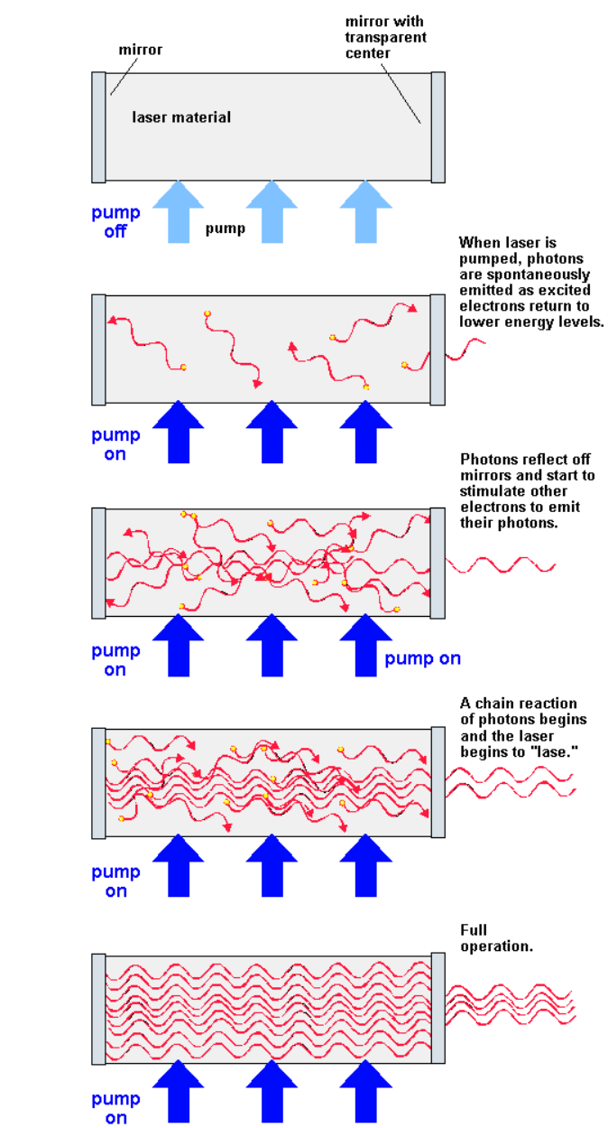

At a specific energy level, some atoms emit particles of light called photons. At first the photons are emitted in all directions. Photons from one atom stimulate emission of photons from other atoms and the light intensity is rapidly amplified.

Mirrors at each end reflect the photons back and forth, continuing this process of stimulated emission and amplification. The photons leave through the partially silvered mirror at one end. This is laser light. The emitted light waves are in phase with one another and are so nearly parallel that they can travel for long distances without spreading.

**Figure 4: Schematic diagram of Laser operation**

**[http://electrons.wikidot.com/principle-and-application-of-laser]**

• **Frequency**: 50,000 (50k) to 200,000 (200k) pulses per second

(Hz) (slower for bathymetry)

**Wavelength:**

• infrared (1500 – 2000 nm) for meteorology – Doppler LiDAR

• near-infrared (1040 - 1060 nm) for terrestrial mapping

• blue-green (500 – 600 nm) for bathymetry

• ultraviolet (250 nm) for meteorology

• eye-safe; low wattage (<1w)

According to our principal objective of this design Lidar in remote sensing as well as in agriculture specially in soil loss measurement, the Nd: YAG Laser-Pumped Hydrogen Raman Shifter has been chosen as the illumination source.

1. **Preferred Nd: YAG Laser**

Nd:YAG lasers are optically pumped using a flashtube or laser diodes. These are one of the most common types of laser and are used for many different applications. Nd:YAG lasers typically emit light with a wavelength of 1064 nm, in the infrared. However, there are also transitions near 946, 1120, 1320, and 1440 nm. Nd:YAG lasers operate in both pulsed and continuous mode. Pulsed Nd:YAG lasers are typically operated in the so-called Q-switching mode: An optical switch is inserted in the laser cavity waiting for a maximum population inversion in the neodymium ions before it opens. Then the light wave can run through the cavity, depopulating the excited laser medium at maximum population inversion. In this Q-switched mode, output powers of 2 watts and pulse durations of 10 to 25 nanoseconds have been achieved.

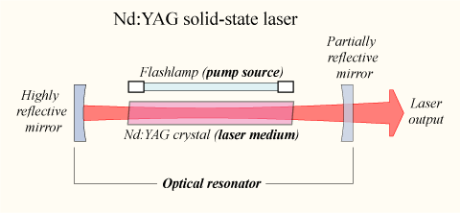

**Figure 5: Nd:YAG Laser working principle**

[https://en.wikipedia.org/wiki/Nd:YAG_laser]

VGEN-SP-NL-25-10 from the Spectral-Physics is selected to continue with this project. Its average output power is 10W. It can provide pulse width of 3ns. The max pulse energy that can be provided by this Laser is 75µJ. The wavelength of the laser matches with the wavelength selected for the purpose. The working voltage of this laser is 12, 24 VDC which makes ideal for the UAV system.

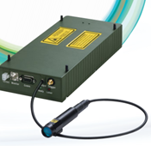

**Figure 6: VGEN-SP-NL-10 Laser**

1. **Principle of Q-switching mode**

Q-switching is achieved by putting some type of variable attenuator inside the laser's optical resonator. When the attenuator is functioning, light which leaves the gain medium does not return, and lasing cannot begin. This attenuation inside the cavity corresponds to a decrease in the Q factor or quality factor of the optical resonator. A high Q factor corresponds to low resonator losses per roundtrip, and vice versa. The variable attenuator is commonly called a "Q-switch", when used for this purpose.

Initially the laser medium is pumped while the Q-switch is set to prevent feedback of light into the gain medium (producing an optical resonator with low Q). This produces a population inversion, but laser operation cannot yet occur since there is no feedback from the resonator. Since the rate of stimulated emission is dependent on the amount of light entering the medium, the amount of energy stored in the gain medium increases as the medium is pumped. Due to losses from spontaneous emission and other processes, after a certain time the stored energy will reach some maximum level; the medium is said to be gain saturated. At this point, the Q-switch device is quickly changed from low to high Q, allowing feedback and the process of optical amplification by stimulated emission to begin. Because of the large amount of energy already stored in the gain medium, the intensity of light in the laser resonator builds up very quickly; this also causes the energy stored in the medium to be depleted almost as quickly. The net result is a short pulse of light output from the laser, known as a giant pulse, which may have a very high peak intensity.

1. **Scanning frequency**

Scanning frequency is the number of pulses or beams emitted by the laser instrument in 1 second. Older instruments emitted a few thousand pulses per second. Modern systems support frequencies of up to 167 kHz (167,000 pulses per second). Sometimes they can be operated at lower-than-maximum frequencies, typically 100 kHz or 71 kHz, but seldom at low frequencies, say, 10 kHz. The scanning frequency is directly related to the density of discrete returns obtained. Thus, a system operating at 150 kHz onboard an aircraft flying at constant speed at a standard height above a target will generate a much higher number of returns than when operating at 71 kHz. Equivalently, a high-frequency system can generate desired return densities by operating on an aircraft that flies higher and faster than an aircraft carrying a lower frequency system, thereby reducing flying time and acquisition costs.

1. **Beam divergence**

Unlike a true laser system, the trajectories of photons in a beam emitted from a LIDAR instrument deviate slightly from the beam propagation line (axis) and form a narrow cone rather than the thin cylinder typical of true laser systems. The term “beam divergence” refers to the increase in beam diameter that occurs as the distance between the laser instrument and a plane that intersects the beam axis increases. Typical beam divergence settings range from 0.1 to 1.0 millirad. At 0.3 millirad, the diameter of the beam at a distance of 1000 m from the instrument is approximately 30 cm (fig. 2). Because the total amount of pulse energy remains constant regardless of the beam divergence, at a larger beam divergence, the pulse energy is spread over a larger area, leading to a lower signal-to-noise ratio.



**Figure 6: Illustration of LIDAR beam divergence.**

** **

**Figure 7: Difference between large and small FOV**

Large FOV usually results in a lower S/N

1. **Scanning angle**

Scanning angle is the angle the beam axis is directed away from the “focal” plane of the LIDAR instrument. The maximum angle supported by most systems does not exceed 15 degrees. The combination of scanning angle and aboveground flight height determines the scanning swath.

1. **Pulse length**

It is the duration of the pulse, in nanoseconds (ns). Along with discretization settings it determines the range resolution of the pulse in multiple return systems, or the minimum distance between consecutive returns from a pulse.

1. **Laser Beam Profile**

Reflectance depends on the laser beam characteristics, particularly the spot size. The larger the spot size, larger the area over which the radiant power is distributed. To get the correct value for the irradiance on should know the area or limiting aperture over which the radiant power is distributed. Usually the most common distribution is Gaussian which assumes peak irradiance in the center. The beam diameter is measured till the point where the irradiance has dropped to 1/e relative to the center. Assuming the it is same we can use hat approximation to calculate the irradiance

|  |  |  |
| --- | --- | --- |
|  |  | **[1]** |

**LiDAR Architecture:**

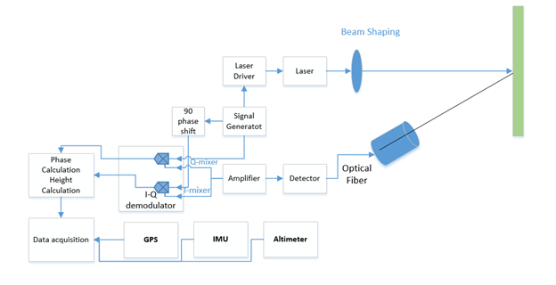

telescope

**Figure 8: Lidar Architecture**

1. **Quadrature Phase Detection**

In this scheme a signal generator is used to generate a signal s1 with a certain waveform and frequency (f). The laser diode driver circuit then uses the signal to modulate the amplitude of the emitted laser beam. The emitted laser light is reflected by an object at a certain height (h) from the UAV and is measured by a photodiode serving as a detector. This will give rise to signal s2 with frequency (f). The collected signal will have some phase difference between then due to the s2 have travelled a total distance of 2h than s1.

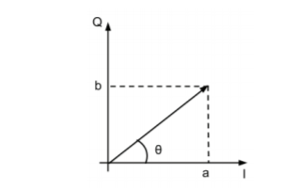The obtained phased difference can be measured by using the mixers. A mixer is a device whose input is two periodic signals. It output is the sum and difference of frequencies. This is achieved through multiplying the input signals in the time domain.

Feeding the mixer with the reflected signal, the output is 2 signals. One instance is mixed with s1 producing the result I and the other is mixed s1’, which is phase shifted by , producing the result Q. This results in a vector in the I-Q-plane, whose argument is the phase difference between s1 and s2 and its magnitude give the amount of light reflected from the object that reached the detector. Since the frequency of both signals is fm, the time t it took for the laser light to travel 2h is easily calculated from the phase difference

Figure 9: I-Q plane

|  |  |  |
| --- | --- | --- |
|  |  | **[2]** |

The benefit of using quadrature phase detection are that we can obtain both the height and reflectance of the ground object measurement are obtained.

1. **Optics:**

Optics can be used in front of the detector to increase the amount of reflected light to the photodetector as possible. This could be achieved by either mirrors or lenses. Since we are using single wavelength monochromatic light neither of the mirror nor lenses will make any difference in the system function. For this project, a plano-convex lens is selected to converge the light to the detectors. The diameter of the lens greatly affects the amount of the light collected at the sensor as increases by two folds.

The power received,, for a certain transmitted power,, can be estimated assuming the no possible absorption on the way to the target at height “h” from the UAV. Assuming the target have a reflectivity, R and reflects in all direction, the received power in the detector with area can be approximated by the equation

|  |  |  |
| --- | --- | --- |
|  |  | **[3]** |

Furthermore, to increase the signal-to-noise ratio an optical bandpass filter can be used to reduce the noise from ambient light.

1. 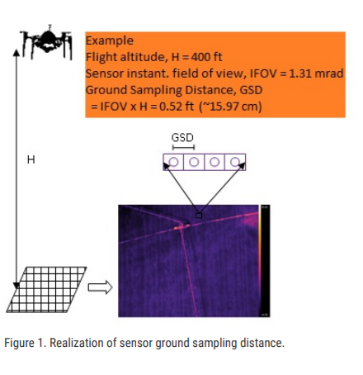**Realization of sensor Ground Sampling Distance:**

In remote sensing, ground sampling distance (GSD) in a digital photo of the ground from air or space is the distance between pixels centers measured on the ground. It is also known as the ground-projected instantaneous field of view (GIFOV). It is a measure of resolution limitations due to sampling. It determines how much details we want from the ground we are observing. It plays a key factor while designing the lidar system. A detector and laser system should be selected considering the height that UAV want to scan the ground target. For a nadir-looking sensor H, these is given by

**Figure 10: Ground Sampling Distance**

|  |  |  |
| --- | --- | --- |
| https://lh3.googleusercontent.com/-0Gzs-QesbAg/WujnY9NcNqI/AAAAAAAAAwE/LSwhwsBetZwWECDdBpXR3nbEWRvo_ue6ACL0BGAYYCw/h500/2018-05-01.png  **Figure 21: Beam Shaping** |  |  |

The purpose of using beam shaping is that, as we increase the distance between target and UAV platform FOV gets increased which decrease the SNR. To reduce this distance effect, beam shaping is performed so that parallel beams are focused on the target.

**Laser Optics:**

The laser beam width and the detector instantaneous field of View (IFOV) should arranged to match with each other. The output light from the laser need to be collimated to produce a well-defined beam. A plano-convex lens could be used to suffice the requirement. It could be placed in such a way that it focuses the LD light at infinity by placing the LD in the focal point. A coating on the lens can be performed for optimization of the wavelength.

1. **Detector Size and Placement**

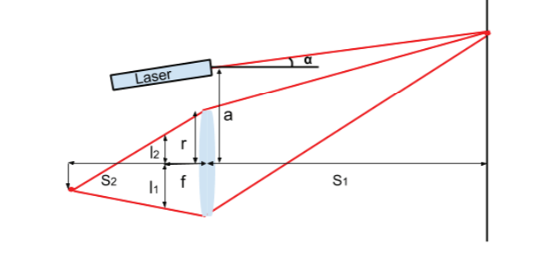For optimum performance the maximum height that UAV planned to fly at should be placed in the focal point, f, of the lens. Maximum height between the ground surface and the UAV is the most important consideration since it returns the least amount of light. To estimate how spread out the laser point is at the focal length for an object at a specific length, S1, first the focus point S2, must be calculated. This can be done using the thin lens equation.

**Figure 12: Schematic of Optics**

|  |  |  |
| --- | --- | --- |
|  |  | **[4]** |

|  |  |  |
| --- | --- | --- |
|  |  | **[5]** |

**Photodetectors:**

Optical Detector performs the conversion of incident light, i.e. optical signal to equivalent electrical signal needed. Photoelectric effect is the phenomenon inside the photodetectors that results the conversion of light to electrical signal. There are many varieties of such devices available which can be adapted. None of them is one above others. To select one for the specific purpose they are needed to be compared with the parameters that best suits for your purpose.

**Properties of Photodetectors:**

1. **Photosensitivity**

This is usually given in units of A/W or V/W, i.e. amps or voltage per watts of incoming optical power depending on type of detector. This is generally present in graph along with the light wavelength. Thus, choice of the detector depends on the wavelength of light which can be detected. It is desirable to have peak sensitivity.

1. **Frequency Response.**

Another most important property of photodetector is its frequency response or bandwidth (BW). It plays important role in selection of the detector when your optical signal is time dependent. This is usually defined in terms of cutoff frequency, , or simply BW, in units of Hz. A fast detector has high , which means it can better reproduce signals which vary fast in the time domain.

1. **Noise-equivalent Power.**

High signal to noise ratio, SNR, is a useful ration for evaluating the performance of the components in a signal processing chain. All detector produce noise when they are operated. When level of signal equals to the level of the noise present in the system, it is not possible to distinguish between them. NEP measures it sensitivity with respect to the minimum optical power at certain wavelength and signal bandwidth it can detect.

**Types of Photodetector:**

1. **Photodiodes.**

A photodiode is its simplest form a pn-junction in an elemental semiconductor such as silicon. When a p-doped and an n-doped region are brought together, free charge carriers, electrons, supplied by the donor atoms in the n-doped region fill the empty state supplied by the acceptor atoms in the p-region, a depletion region with no free charge carriers is formed. The width of the depletion region depends on the n and p dopant concentration and voltage applied to the junction.

In the presence of an electric field inside the depletion region, any free charges generated by illuminating the junction will be separated and swept away from where they were generated. This effectively stops them from recombining, resulting in a current whose magnitude depends on the photon incident to the junction. This photocurrent is a linear function of the incoming light. The frequency response is quite fast. This configuration is called photoconductive method.

1. **The PIN diode.**

It is not desirable to have recombination in the depletion region if the diode is operated in the photoconductive mode. Thus, to suppress recombination and to simultaneously favor electron-hole pair generation by increasing the area where this occurs, one option is to add an intrinsic layer between the p- and n-doped sides, where the majority of the electron holes pairs are generated. This is called a p-i-n diode or PIN diode, named after the p-doped intrinsic and n-doped areas.

1. **Avalanche Photodiode- APD**

By increasing the reverse bias of a diode, one eventually reaches the breakdown voltage and the diode begins conduction a large current in the opposite direction. This is usually damaging for the diode and is with some exceptions an undesirable operation. However, by applying large reverse bias, typically 100-200V in a Si APD diode, but remaining below the breakdown voltage, the diode may exhibit the so-called avalanche effect which essentially provides internal gain, M, for the converted optical signal.

1. **Photoresistors.**

A photoresistor is a device whose electrical resistance decreases as incident light intensity increase. They are based on semiconductor, either intrinsic or extrinsic and their properties such as wavelength dependent sensitivity can thus be controlled. Incident photons with energies in a certain material dependent region excite electrons from the valence band to the conduction band, i.e. create an electron-hole pair, and these free charge carriers can they carry a current, lowers the resistance of the device.

They typically slow devices, with rise and fall times in the milli second range. The resistance varies with the temperature.

1. **Photo Transistors.**

Phototransistor is a homojunction bipolar transistor that has been optimized to work as a photodetector. This is done in part by increasing the size of the base and collector regions, since it is in the base-collector junction that the incoming photos generate most of the electron-hole pairs which constitute the base current.

The most disadvantage of homojunction phototransistor is that they are quite slow

1. **Photomultiplier Tube (PMT)**

PMT is highly sensitive and fast photoreceivers. They are used in research to measure extremely low levels of light or even to register single photons. The device typically consists of a cathode, several dynodes and an anode suspended in some vacuum tube with an electric field applied. The incoming photos cause emission of electrons from cathode.

These detectors produce less noise than the APD.

1. **Charge Coupled Device – CCD**

The sensor is divided in smaller parts called pixels and each pixel works as small photodetector. During a certain amount of time, the pixels gather photons and when the time is up, the number of electrons generated in the pixels by the incident photon is counted. Then this number is then related to the intensity of light at that pixel.

**Selection of Photodetectors.**

The basic requirement of the photodetector to be suitable for the homodyne receiver are speed and sensitivity. The primary requirement is the sensitivity of the laser wavelength in the range of 976 nm must highly sensitive. Secondly, the bandwidth must be sufficiently large to be able detect the modulate signals.

These two requirement filters out photodetectors such as photoresistor, phototransistor. PMT detector are filtered due to requirement of high voltage to bias them. It is difficult to get such high voltage in UAV. The two detector that fulfills the requirement are PIN and the APD. Due to the experience with the PIN diode, the PIN diode is selected for the report. As PIN diode operates at max 20V and min 5V reverse bias it will be easier to handle in UAV than the APD.

**Selected Photodiode.**

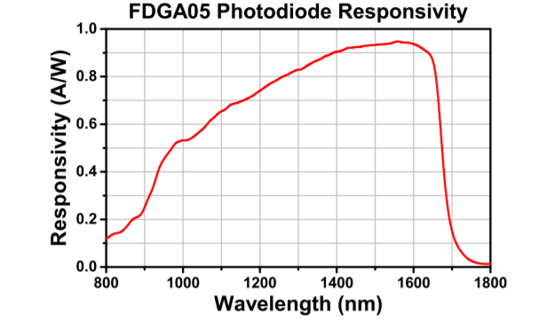Although there are a lot of PIN diode available for NIR wavelength Thorlabs FDGA05, InGaAs, is selected for this analysis. This photodiode has high rise and fall time of 2.5ns. The wavelength ranges from 800-1700nm which reduces the possible noise due visible light. The junction capacitance is low compared to other detectors. The dark current is in the region of 0.05nA which makes very suitable for the NIR detection. The cost of the detector is $103 per piece. The data collected will highly depend on the detector so high-quality detector is selected.

**Figure 13: Responsivity of FDGA05**

**Transmitter Circuit Design**

1. **Detector Circuit Design:**

The detector converts the light detected into an electrical signal. To be more specific the light, FDGA05 provides the detected signal as a change in the current. The first part of the amplifier circuit need to convert that current into the proper voltage that can be used for further signal conditioning.

1. **Front-end amplifier:**

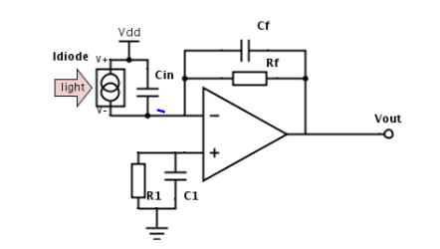Transimpedance amplifier (TIA) is used as the initial amplification to convert the current signal produced by the photodiode to a voltage. The transimpedance amplifier presents a low impedance to the photodiode and isolates it from the output voltage of the operational amplifier. In its simplest form a transimpedance amplifier has just a large-valued feedback resistor, Rf. The gain of the amplifier is set by this resistor and has a value of Rf (because the amplifier is in an inverting configuration). Noise in the first stage amplification should be very low. Therefore, ada4817 amplifier is selected for the amplification. It has very low current noise, i.e. and sufficient bandwidth to handle the signal.

**Figure 14: Transimpedance Amplifier**

To avoid any DC voltage amplification, should be equal to . This configuration removes any DC offset at the output.

**AC analysis of Transimpedance Circuit.**

The gain is set by and the bandwidth is limited to . The in parallel with provides the stability to the circuit. The capacitor at the non-inverting terminal of the amplifier provides the AC ground and shorts out the noise. The transfer function of the circuit is given by

|  |  |  |
| --- | --- | --- |
|  |  | **[6]** |

To be at safe side of instability a larger value of should be introduced in the circuit. However, introducing larger will limit the bandwidth. To maximize bandwidth without risking instability, the pole should be placed at the frequency where A=

|  |  |  |
| --- | --- | --- |
|  |  | **[7]** |

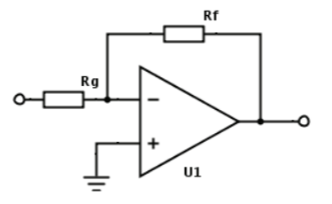

1. **Second Stage Amplifier:**

The second stage amplifier is needed for the amplification of the voltage to the desired level. A low noise inverting amplifier can be used as amplifier. LM 541 amplifier can be selected as amplifier for the second stage. The gain of the amplifier is given by the ratio of feedback resistor to input resistance.

**Figure 15: Second stage Amplifier**

1. **Demodulation:**

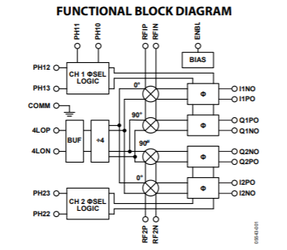An IQ-demodulator IC (AD8333) can be used for phase shifting and mixing. The AD8333 is a dual phase-shifter and I/Q demodulator that enables coherent summing and phase alignment of multiple analog data channels. It is the first solid state device suitable for beam former circuits featuring CW Doppler. A divide-by-4 circuits generates the internal 0 and 90-degree phase of the local oscillator(LO) that drive the mixers of a pair of matched I/Q demodulator.

**Figure 16: Block Diagram of the AD8333**

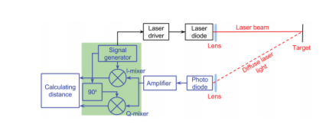

**Figure 17: IQ -demodulation Section**

**GPS in UAV Lidar system**

The performance of UAV is dependent greatly upon onboard sensors due to its characteristics of unmanned operated vehicle. The navigation sensor, which informs where UAV is flying, also is one of those onboard sensors. Small UAV needs the navigation system with the compact, light, cheap and precise navigation solution. As the inertial sensor for precise air navigation is very expensive, it is not popular in small aircraft and UAV. While GPS services a seamless navigation with cheap receiver, it may not receive the satellite signal by the obstacles or the signal jamming. It is GPS/INS sensor fusion that might overcome these constraints. GPS receiver on air vehicle may happen to lose the signal in a dynamic environment such as aircraft maneuver. The multiple GPS antennas were used to increase the coverage of GPS receiver. The ground test showed that GPS/INS sensor fusion system could provide well the attitude information as well as the trajectory according to a vehicle movement**.**

**Inertial Measurement Unit:**

An inertial measurement unit works by detecting the current rate of acceleration using one or more accelerometers. The IMU detects changes in rotational attributes like pitch, roll and yaw using one or more gyroscopes. Some IMU on drones include a magnetometer, mostly to assist calibration against orientation drift.

A computer continually calculates the vehicle’s current position. First, it integrates the sensed acceleration, together with an estimate of gravity, to calculate the current velocity. Then it integrates the velocity to calculate the current position.

To fly in any direction, the flight controller gathers the IMU data on present positioning, then sends new data to the motor electronic speed controllers (ESC). These electronic speed controllers signal to the motors the level of thrust and speed required for the quadcopter to fly or hover**.**

**Altimeter**

Altimeters are devices designed to calculate the height of an aircraft above the surface directly below it. This height may be Above Ground Level (AGL) or Above Sea Level (ASL). Different types of altimeter use different technologies to calculate this height, including pressure-density to altitude relationship and the propagation and reflection of electromagnetic waves etc. altimeters are generally used for maintaining a constant altitude.

**Laser altimeter**

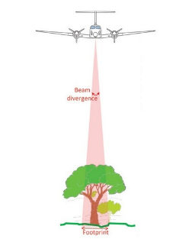This type of altimeter works by using electromagnetic waves within the visible range of the spectrum instead of radio waves. Laser altimeters work in a similar way to radio altimeters. Again, the time taken for the emitted signal to travel from the transmitter to the surface and back again is measured. Once reflected, the beam of light is received and collected using a series of mirrors and lenses which focus the beam onto a photocell detector which is sensitive to infrared light.

Figure 18: Necessity of altimeter in UAV system

**TABLE 1: Approximate Cost Estimation of the proposed design**

|  |  |  |  |  |
| --- | --- | --- | --- | --- |
| **S. N** | **Components** | **Unit** | **Prices ($) per unit** | **Price** |
| 1. | VGEN-SP-NL-25-10 | 1 | 4000 | 4000 |
| 2. | FDGA05 | 1 | 103 | 103 |
| 3. | Telescope | 1 |  |  |
| 4. | MTK3339 (GPS) | 1 | 29.95 | 29.95 |
| 5. | LSM303DLHC (Compass + Accelerometer) | 1 | 14 | 14 |
| 6. | BMP280 (Altitude Sensor) | 1 | 9.95 | 9.95 |
| 7. | AD8333 (Demodulator) | 1 | 352 | 352 |
| 8 | Ada 4817 (Amplifier) | 2 | 5 | 10 |
| 9 | OPA 541 (Amplifier) | 1 | 15 | 15 |
| 10 | Signal Generator (ADF4355) | 1 | 110.88 | 110.88 |
| **Total** | | | | **$4634.8** |

**TABLE 2: Designed Parameters Specification**

|  |  |  |
| --- | --- | --- |
| **S. N** | **Properties** |  |
|  | Proposed Distance between Surface and UAV(approx.) | 100m |
|  | Laser Wavelength | 1064nm |
|  | Pulse Energy | 0.6µJ |
|  | Pulse Repetition Frequency | GHz range |
|  | Ground Sampling Distance | 15cm |
|  | Receiver wavelength | 800-1800nm |
|  | Telescope Diameter (approx.) | 2.5cm |

**Conclusion**

This report provides general overview Lidar design to determine the health condition of the Plant. The proposed laser design gives the resolution of 15 cm. The design specification has been made taking into consideration health hazards. To maintain eye safety pulse energy has been limited to 0.6 micro joule. The design considers all the parameters that could un stabilize the system. The Lidar is design to be payload on UAV such as quadcopter. Push-broom scanning technique is used as it is a lot easier to handle and reduces the load in the UAV. The data generated by this lidar will contain details about its speed at which measurement was done, altitude, GPS location, the angle of the direction in which it is moving, time and reflectance from the ground surface.

**References**

1. [**http://superlidar.colorado.edu/Classes/Lidar2014/LidarLecture31_LidarDesignConsiderations.pdf**](http://superlidar.colorado.edu/Classes/Lidar2014/LidarLecture31_LidarDesignConsiderations.pdf)
2. [**http://www.nuffieldscholar.org/news/davina-fillingham-report-published**](http://www.nuffieldscholar.org/news/davina-fillingham-report-published)
3. [**https://www.laserfocusworld.com/articles/print/volume-53/issue-03/features/lasers-for-lidar-application-parameters-dictate-laser-source-selection-in-lidar-systems.html**](https://www.laserfocusworld.com/articles/print/volume-53/issue-03/features/lasers-for-lidar-application-parameters-dictate-laser-source-selection-in-lidar-systems.html)
4. [**http://blog.rpmclasers.com/lasers-lidar**](http://blog.rpmclasers.com/lasers-lidar)
5. [**http://www.mdpi.com/journal/remotesensing/special_issues/lidar_rs**](http://www.mdpi.com/journal/remotesensing/special_issues/lidar_rs)
6. [**http://robots.engin.umich.edu/~rwolcott/uploads/rwolcott-2014a.pdf**](http://robots.engin.umich.edu/~rwolcott/uploads/rwolcott-2014a.pdf)